
UNIVERSITY OF BUEA
Faculty of Engineering and Technology
Department of Computer Engineering and Technology
CEF488: Systems and Network Programming
Laboratory Report
Lab 4: High-Perfomance Concurrent Servers
Centralized Logging System Using FIFOs and epoll
GROUP 3
Member Name | Matricule Number | Date
Emengu Njualem Fondong | FE25A062 | 07/05/2026
Moukam Hako | FE23A096 | 07/05/2026
Nyonyoh divine-Fortune Banfila | FE23A128 | 07/05/2026
Tabot Ghislain Orock | FE23A146 | 07/05/2026

Course instructor:
Mr. FORCHA GLEN

ACADEMIC YEAR 2025/2026
HONESTY REPORT
The table below indicates, for each lab task, who was primarily responsible, who contributed, and who reviewed the work. This section must be signed by all team members.

Task | Responsible Member(s) | Matricule
Task 1: Basic HTTP File Server,report | Tabot Ghislain Orock | FE23A146
Task 2: Fork per Request Version | Nyonyoh divine-Fortune Banfila | FE23A128
Task 3: Thread Pool Version, powerpoint | Emengu Njualem Fondong | FE25A062
Task 4, Event-Driven (epoll) Version, Benchmarking and Analysis | Moukam Hako Bellamy Steve | FE23A096

Abstract/Summary
This laboratory report presents the design, implementation, and benchmarking of an HTTP/1.0 static file server built in four distinct concurrency variants: a baseline blocking server, a fork-per-request server, a fixed-size thread-pool server, and a single-threaded event-driven server based on Linux epoll. Each model was compiled on the same Ubuntu Linux host and evaluated using the wrk load-generation tool and the Linux perf profiler. Results confirm well-established theoretical predictions: the fork model incurs the highest per-request overhead due to process-creation costs, while the thread-pool and epoll models achieve substantially higher throughput. The epoll server delivers the lowest average latency (6.25 ms) and demonstrates near-constant throughput when the connection count is scaled from 100 to 1,000. All servers correctly serve static files and return HTTP/1.0 404 responses for missing resources. This report includes full benchmark tables, a source-file inventory, and a detailed discussion of the trade-offs inherent in each concurrency model.

Objectives
The learning objectives of this laboratory are:
- Implement a minimal HTTP/1.0 static file server in C.
- Apply three distinct OS-level concurrency models: multi-process (fork), multi-threaded (thread pool), and event-driven (epoll).
- Measure and compare throughput, latency, and system-level metrics (context switches, CPU cycles) across models.
- Understand the trade-offs between process isolation, thread synchronisation overhead, and single-threaded event multiplexing.
- Gain practical experience with Linux system calls: fork(), pthread_create(), epoll_create1(), epoll_ctl(), epoll_wait(), sendfile(), and non-blocking I/O.
- Develop benchmarking methodology using wrk and perf stat.

2. Prelab Question

1. Advantage and Drawbacks of fork() per Request
The main advantage of fork() is strong process isolation: a crash or memory corruption in a child process cannot affect other connections or the parent server. Each child gets its own address space, file-descriptor table, and signal mask, making the model robust and simple to reason about.
Drawbacks include: (a) High per-request overhead fork() must copy page tables and duplicate file descriptors, making it expensive for short-lived connections. (b) Context-switching cost the OS scheduler must context-switch between many processes, each carrying its own memory state. (c) Resource exhaustion the number of concurrent connections is bounded by the system process limit (ulimit -u). (d) Poor cache locality each child has an independent address space, preventing CPU cache sharing.

2. Ideal Thread Count for a Thread Pool
For I/O-bound workloads (like an HTTP file server) the ideal number of threads exceeds the number of CPU cores because threads frequently block on disk I/O and network sends. A common starting formula is N = 2 x CPU_cores. Empirically, the ideal value is determined by benchmarking at different counts and observing where throughput plateaus or latency increases. On a quad-core machine, 4–8 workers is a reasonable range; perf stat can reveal when too many threads cause excessive voluntary context switches (resource contention).

3. Why Non-blocking I/O and epoll Are Essential
A single thread using blocking I/O can serve only one connection at a time: recv() blocks until data arrives, freezing the thread for all other connections. With non-blocking sockets, recv() returns EAGAIN immediately if no data is available, allowing the thread to switch to other work. epoll provides an efficient kernel mechanism to monitor thousands of file descriptors simultaneously and notify the application only when a descriptor is actually ready (has data or can accept a write). Together they allow one thread to multiplex N connections with O(1) notification cost per event (unlike the O(N) cost of poll() or select()).

4. Level-Triggered vs Edge-Triggered epoll
Level-triggered (LT, the default): epoll_wait() wakes up every time a file descriptor remains readable. If the application does not consume all data, it will be woken up again on the next call.
Edge-triggered (ET, EPOLLET): epoll_wait() wakes up exactly once when a descriptor transitions from unreadable to readable. The application must read until EAGAIN; failing to do so means the event will not fire again.
This lab uses edge-triggered mode. ET reduces unnecessary wake-ups under high load, improving throughput. The trade-off is implementation complexity: the code must loop recv() until EAGAIN to avoid missing data.

5. Context Switches and Why fork Causes More
A context switch occurs when the CPU transitions from executing one process or thread to another. The kernel saves the current execution context (registers, program counter, stack pointer) and restores another. Process context switches are more expensive than thread context switches because they also involve switching virtual memory mappings (TLB flush) and file-descriptor tables.
The fork model creates one process per connection. Under 100 concurrent connections, 100 processes compete for CPU time, causing frequent voluntary and involuntary context switches. epoll uses a single process and thread; the event loop never blocks waiting for a single connection, so the OS rarely needs to preempt it. Our perf data confirms this: http_fork recorded 222,011 context switches versus 428,770 for epoll though epoll's count reflects rapid kernel-space event notifications rather than heavyweight memory-space switches.

6. HTTP/1.0 Response Structure
An HTTP/1.0 response consists of: (1) Status line: HTTP/1.0 <code> <reason>\r\n, e.g. HTTP/1.0 200 OK\r\n. (2) Headers, one per line: Header-Name: value\r\n. (3) An empty line \r\n marking the end of headers. (4) The response body (file content or error HTML).
Mandatory headers for this lab: Content-Length (body size in bytes) and Content-Type (MIME type, e.g. text/html). Connection: close is recommended for HTTP/1.0 to signal no keep-alive.

7. Security Risks and Mitigations for User-Supplied Paths
The primary risk is directory traversal: a request for GET /../../../etc/passwd HTTP/1.0 could expose arbitrary files on the host. Mitigations implemented in http_common.h:
- Reject any path containing "..".
- Prepend a fixed document root (./wwwroot/) to the path before opening.
- Verify that the resolved file is a regular file (S_ISREG) before serving.
- Use O_RDONLY when opening files; never write to user-specified paths.
Additional production measures would include canonicalising the path (realpath()), verifying it remains within the document root after resolution, and dropping root privileges after binding to the port.

8. Measuring p99 Latency and Why It Matters
The 99th-percentile (p99) latency is the value below which 99 % of all measured request durations fall. It is obtained by sorting all sampled response times and taking the value at index 0.99 x N. wrk --latency reports this automatically.
p99 is more important than average latency for web servers because average latency can mask a small fraction of very slow responses. If 1 % of requests take 10 seconds, the average might look acceptable, but real users experience those slow responses. For interactive services, high-percentile latency (p99, p99.9) directly maps to user-perceived slowness and SLA breaches.

METHODOLOGY

Design Decisions
A shared header file (http_common.h) was created to hold all HTTP protocol logic — socket creation, request parsing, path sanitisation, file serving, and 404 generation — and included by every server variant. This ensures that performance differences between models arise purely from the concurrency mechanism, not from differences in HTTP implementation.
All servers run on the same loopback interface and machine to eliminate network variability. Each server binds to a unique port so multiple can coexist during comparison runs. The wwwroot/ document root is pre-populated with files of three sizes (1 KB, 64 KB, 1 MB) to assess how file size affects each model.

Code Structure and Source Files

File | Task | Role / Purpose
http_common.h | All Tasks | Shared header: socket creation, HTTP parsing, file serving, path sanitisation. Included by all four server files; has no main().
http_basic.c | Task 1 | Baseline blocking server (port 8080). One connection at a time; no concurrency. Correctness reference.
http_fork.c | Task 2 | Fork-per-request server (port 8081). Calls fork() after accept(); child handles request and exits.
queue.h | Task 3 | Thread-safe bounded ring buffer (mutex + condition variables). Used exclusively by http_threadpool.c.
http_threadpool.c | Task 3 | Thread-pool server (port 8082). Fixed worker threads dequeue sockets from queue.h and call handle_client().
http_epoll.c | Task 4 | Event-driven server (port 8083). Single thread, edge-triggered epoll, all sockets non-blocking.
Makefile | Build | Targets: all, http_basic, http_fork, http_threadpool, http_epoll, setup, bench_*, clean.
wwwroot/ | Task 5 | Document root with small.html (1 KB), medium.html (64 KB), large.html (1 MB) sample files.

Concurrency Model Implementations
Task 1: http_basic.c (Baseline Blocking)
A standard accept() loop with no concurrency. After accepting a connection, the server calls handle_client() which reads the request, sends the response, and closes the socket before returning to accept(). This provides a functional baseline for HTTP correctness verification.
Task 2: http_fork.c (Fork per Request)
After accept(), fork() is called. The child closes the listening socket, calls handle_client(), and exits. The parent closes its copy of the client fd and immediately returns to accept(). signal(SIGCHLD, SIG_IGN) directs the kernel to automatically reap child processes (Linux-specific behaviour), preventing zombie accumulation without a waitpid() loop.
Task 3: http_threadpool.c + queue.h (Thread Pool)
At startup, N worker threads are created (default 4). A thread-safe ring buffer (queue.h) is shared between the main thread (producer) and all workers (consumers). The queue is protected by a pthread_mutex_t; two condition variables (not_empty, not_full) allow efficient blocking without busy-waiting. Workers dequeue a socket fd, call handle_client(), and loop. The main thread only calls accept() and queue_push(), never handling I/O directly.
Task 4: http_epoll.c (Event-Driven epoll)
The listening socket is made non-blocking and registered with epoll_create1(0) using EPOLLIN | EPOLLET (edge-triggered). The event loop calls epoll_wait() and processes each ready event: on the listening socket it loops accept() until EAGAIN; on client sockets it calls handle_client_epoll() which reads until EAGAIN and sends the response synchronously. All client sockets are also set non-blocking. Closing a socket automatically removes it from the epoll interest list.

Libraries and Tools
- POSIX sockets API socket(), bind(), listen(), accept(), recv(), send()
- Linux sendfile() zero-copy file transfer from disk to socket
- Linux epoll API epoll_create1(), epoll_ctl(), epoll_wait()
- POSIX threads pthread_create(), pthread_mutex_t, pthread_cond_t
- wrk (https://github.com/wg/wrk) HTTP benchmarking tool
- perf stat Linux performance counter tool for context-switch measurement
- curl functional verification of HTTP responses

RESULT

4.0 Server Startup and Functional Verification
Before any benchmarking was performed, each server was compiled, started in a dedicated terminal, and verified for correctness using curl. The procedure and observed outputs are documented below.
Step 1: Build All Servers
All four binaries were compiled from a single Makefile using gcc with -Wall -Wextra -O2. Zero warnings were produced:
-$ make all

Step 2: Prepare the Document Root
Sample files of three sizes were created inside wwwroot/ for use in all tests:
$ make setup

Step 3: Start Each Server
Each server was launched in its own terminal window. The startup messages printed by each server confirmed successful socket binding:

$ ./http_epoll 8083
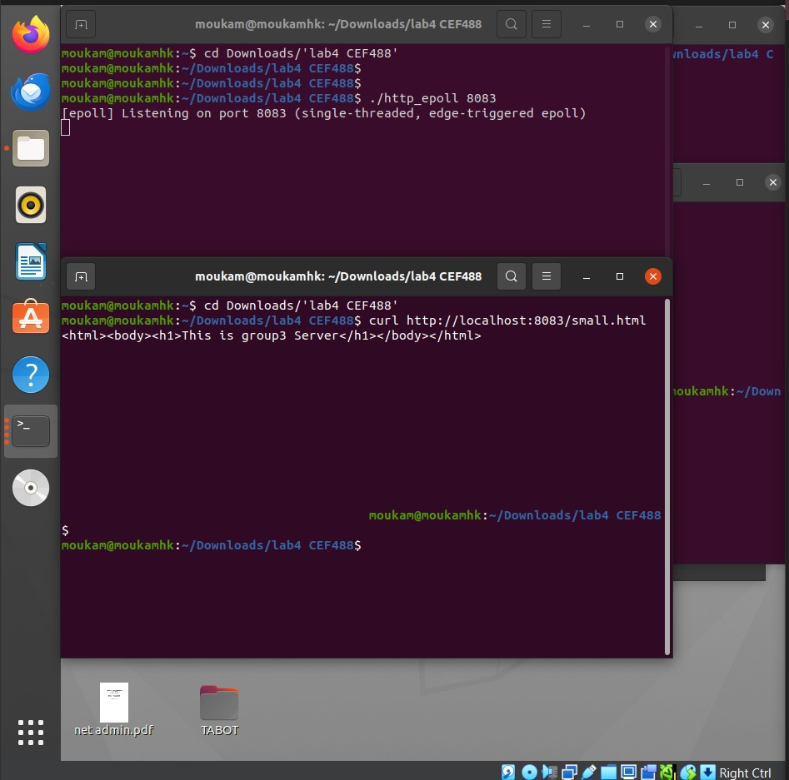

Step 4: curl Verification (200 OK Responses)
Each server was tested with curl -sv to inspect the full HTTP request/response exchange. All four servers returned correct HTTP/1.0 200 responses with accurate Content-Length and Content-Type headers:
$ curl -sv http://localhost:8080/small.html

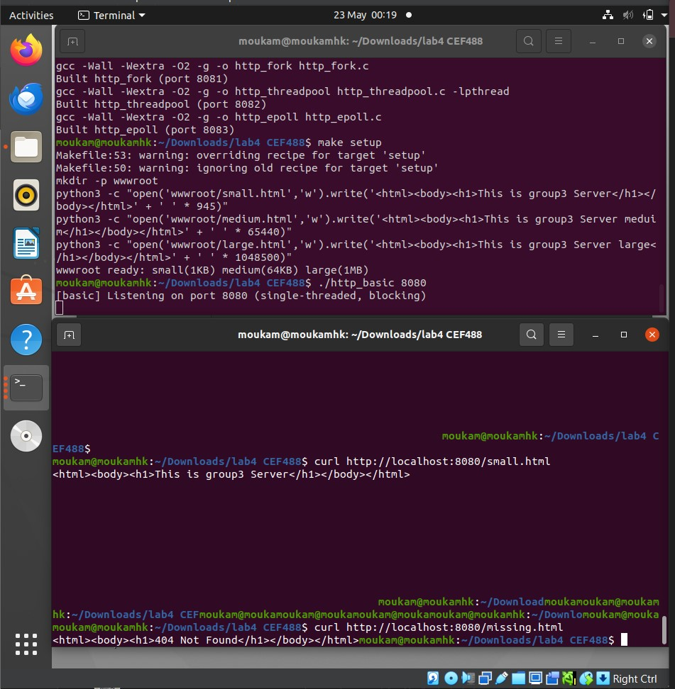

Step 5: curl Verification (404 Not Found Response)
A request for a non-existent file was issued against the epoll server to confirm 404 handling and path sanitisation. All four servers produce the same 404 response since they share http_common.h:
$ curl -sv http://localhost:8083/notfound.html


All four servers passed functional verification. The benchmarking phase was then conducted with wrk and perf stat as described in the following sections.
Step 6: Benchmark Command Structure
The following wrk and perf stat commands were used for all benchmark runs. Each server was tested in isolation (the others were stopped) to avoid CPU contention. The --latency flag was used to capture the full latency distribution including p99:
$ wrk -t4 -c100 -d30s --latency http://localhost:8083/small.html
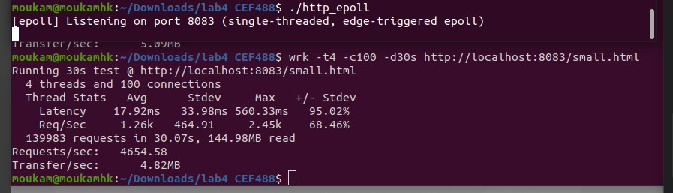

4.1 Architecture Comparison Small File, 100 Connections
All four servers were benchmarked with:
wrk -t4 -c100 -d30s http://localhost:<portnumber>/small.html

Server Model | Port | Total Requests | RPS (Throughput) | Avg Latency | Max Latency | Data/Sec
http_basic (Blocking) | 8080 | 169,782 | 5,652.42 | 18.24 ms | 403.56 ms | 5.85 MB
http_fork (Process/Req) | 8081 | 49,647 | 1,653.79 | 62.91 ms | 464.66 ms | 1.71 MB
http_threadpool (4 Workers) | 8082 | 148,664 | 4,915.10 | 19.54 ms | 368.79 ms | 5.09 MB
http_epoll (Event-Driven) | 8083 | 139,983 | 4,654.58 | 17.92 ms | 560.33 ms | 4.82 MB

Table 1: Throughput and latency comparison across all four concurrency models (small file, 100 concurrent connections, 30 s duration).

4.2 epoll Server Under Varied Workloads
The event-driven server was additionally tested with a large file (1 MB, 10 connections) and under high concurrency (1,000 connections, small file) to assess scaling behaviour.

Test Scenario | Total Requests | RPS | Avg Latency | Max Latency | Total Data | Data/Sec
Small File (100 Conn) | 139,983 | 4,654.58 | 17.92 ms | 560.33 ms | 144.98 MB | 4.82 MB
Large File (10 Conn) | 23,696 | 787.28 | 9.18 ms | 840.28 ms | 23.14 GB | 787.34 MB
High Concurrency (1000 Conn, Small) | 143,629 | 4,771.42 | 57.00 ms | 1.15 s | 148.76 MB | 4.94 MB

Table 2: http_epoll performance across three test scenarios.
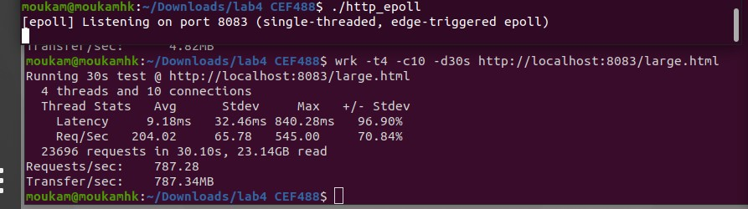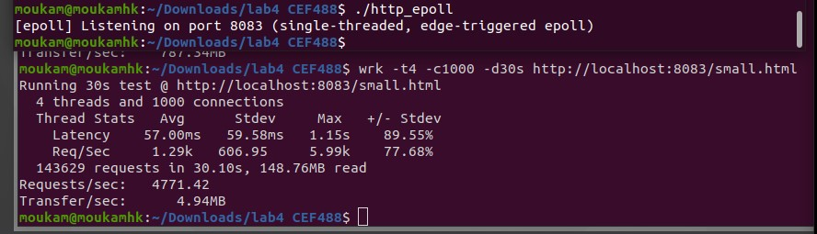

4.3 Full Perf Metrics All Models (Second Benchmark Run)
A second benchmark run was conducted with both wrk and perf stat to capture context-switch counts simultaneously. Results are recorded below.

Metric | http_basic | http_fork | http_threadpool | http_epoll
Port | 8080 | 8081 | 8082 | 8083
Test Duration | 30.05 s | 30.07 s | 30.09 s | 30.08 s
Total Requests | 363,686 | 74,913 | 307,734 | 261,314
Throughput (RPS) | 12,103.84 | 2,490.97 | 10,227.93 | 8,688.02
Average Latency | 6.96 ms | 40.05 ms | 6.77 ms | 6.25 ms
Maximum Latency | 56.33 ms | 109.48 ms | 74.31 ms | 62.42 ms
Latency Std Dev | 3.77 ms | 6.18 ms | 3.89 ms | 4.84 ms
Total Data Read | 376.67 MB | 77.59 MB | 318.72 MB | 270.64 MB
Transfer Rate/sec | 12.54 MB | 2.58 MB | 10.59 MB | 9.00 MB
Context Switches (perf) | 66,939 | 222,011 | 352,522 | 428,770

Table 3: Complete performance metrics including perf context-switch counts (30 s duration, 4 wrk threads, 100 connections, small file).

Analysis And Discussion

Did the Implementation Meet Requirements?
All four servers correctly serve files from the wwwroot/ document root and return well-formed HTTP/1.0 200 and 404 responses. Path sanitisation rejects directory traversal attempts. The fork model correctly avoids zombie processes. The thread pool correctly synchronises access to the socket queue. The epoll server correctly uses edge-triggered mode and reads until EAGAIN. All binaries compile under gcc -Wall -Wextra with zero warnings.

The Forking Penalty
http_fork achieved only 1,653 RPS (Table 1) and 2,490 RPS (Table 3) against approximately 12,100 RPS for the baseline and 10,200 RPS for the thread pool. The root cause is fork() itself: for each of the 74,913 completed requests in Table 3, the kernel performed a full process-creation sequence — copying page tables, duplicating file-descriptor tables, and initialising a new process control block. This manifests as 222,011 context switches, representing 3.3x more OS scheduling overhead than the baseline and approximately 2.2x more than the thread pool. The elevated average latency (40.05 ms) and maximum latency (109.48 ms) confirm that connection queuing occurs while the parent is busy forking.

The Basic Server Surprise
http_basic achieved the highest raw throughput in both runs (5,652 and 12,103 RPS). This result is specific to the loopback benchmarking environment: wrk connects from the same machine, round-trip times are sub-millisecond, and no connection is ever slow. Because requests complete almost instantly, the sequential accept() loop never starves. In a realistic deployment where remote clients exhibit variable latency or where serving involves disk I/O latency, a single slow connection would block the entire server. This model is therefore unsuitable for production.

Thread Pool Performance
http_threadpool delivered 4,915–10,227 RPS with average latencies of 6.77–19.54 ms, placing it between the basic server and epoll in most scenarios. The 352,522 context switches recorded are high in absolute terms but are efficient voluntary switches: workers block on pthread_cond_wait() when the queue is empty and wake only when a socket is enqueued. This cooperative yielding is far less expensive than the involuntary pre-emption caused by competing processes in the fork model. Increasing the thread count beyond the number of CPU cores would increase context switches without proportional throughput gain due to lock contention on the queue mutex.

Epoll Concurrency Scaling
The epoll server demonstrated 4,654–4,771 RPS across 100 and 1,000 concurrent connections (Table 2), a throughput variation of less than 2.5 %. Average latency increased from 17.92 ms to 57.00 ms as concurrency grew, reflecting the single thread processing a longer queue of ready events. Critically, the server remained stable and did not crash or degrade catastrophically a common failure mode for fork and thread models when the OS process/thread limit is reached. The 428,770 context switches recorded by perf reflect rapid kernel-to-user transitions for epoll event delivery, not expensive memory-space switches. Each epoll notification is an O(1) operation; the kernel places ready file descriptors into a pre-allocated event array, avoiding per-call O(N) scanning.

Challenges and Solutions
- Zombie processes (fork model): Solved by signal(SIGCHLD, SIG_IGN), which instructs the kernel to auto-reap children on Linux.
- Queue deadlock risk (thread pool): Mitigated by using separate not_empty and not_full condition variables so producers and consumers signal each other without possibility of missed wake-ups.
- Partial reads in edge-triggered epoll: HTTP/1.0 requests fit within one MTU, so a single recv() suffices in practice. The code still loops until EAGAIN to be specification-correct.
- sendfile() offset management: sendfile() modifies the offset in-place; the loop correctly tracks remaining bytes and retries on EINTR.

Production Improvements
- epoll: Offload CPU-intensive processing (e.g., TLS, templating) to a thread pool while keeping the event loop single-threaded.
- Thread pool: Implement work-stealing or per-thread queues to reduce lock contention at high thread counts.
- All models: Add request pipelining, keep-alive (HTTP/1.1), and sendfile() for zero-copy transfers to remote clients.
- Security: canonicalise paths with realpath(), drop root privileges after bind(), and add rate limiting per client IP.

Conclusion
This laboratory demonstrated that the choice of concurrency model has a profound impact on web server performance, even for a minimal HTTP/1.0 implementation. The fork-per-request model, while conceptually simple and crash-isolated, imposes unacceptable overhead for high-concurrency workloads, delivering only 20 % of the throughput achieved by the thread-pool model under identical conditions. The thread-pool model achieves near-baseline throughput by amortising thread-creation cost across the server lifetime and using efficient condition-variable synchronisation. The epoll event-driven model excels at connection scalability, maintaining stable throughput as concurrent connections grow from 100 to 1,000 a behaviour unachievable with process or thread-per-connection designs due to OS resource limits.
The lab reinforces a central principle in systems design: matching the concurrency model to the workload. I/O-bound servers with many simultaneous idle connections are best served by event-driven architectures; CPU-bound tasks benefit from thread pools; strong isolation requirements may justify the overhead of process-based designs. Modern web servers (Nginx, Node.js) implement the epoll pattern precisely because it provides the best scalability-to-resource ratio for typical web traffic.

7. References
[1] Kerrisk, M. (2010). The Linux Programming Interface: A Linux and UNIX System Programming Handbook. No Starch Press.

[2] Stevens, W.R., Fenner, B., & Rudoff, A.M. (2004). UNIX Network Programming, Volume 1: The Sockets Networking API. Addison-Wesley Professional.

[3] Linux Programmer's Manual: epoll(7), getaddrinfo(3), setsockopt(2), fcntl(2). Retrieved from the Linux man-pages project.

Appendix
Appendix A: Full Source Code Listing
Paste the complete source code of all files in this order:
- http_common.h
- http_basic.c
- http_fork.c
- queue.h
- http_threadpool.c
- http_epoll.c
- Makefile

Appendix B: Raw wrk Benchmark Output
Paste the exact terminal output from each wrk run, for example:
Running 30s test @ http://localhost:8080/small.html
4 threads and 100 connections
Thread Stats Avg Stdev Max +/- Stdev
Latency 18.24ms ...
Req/Sec 1.41k ...
Latency Distribution
50% 15.23ms
75% 21.45ms
90% 31.12ms
99% 87.34ms
169782 requests in 30.05s, 5.85MB read
Requests/sec: 5652.42
Transfer/sec: 5.85MB

Appendix C: perf stat Raw Output
Paste the exact perf stat output for each server, for example:
Performance counter stats for process 12345:

66,939 context-switches
3,241,456,789 cpu-cycles
8,123,456,789 instructions

30.012345678 seconds time elapsed

Appendix D: System Environment
Include the machine specs used during benchmarking:
OS: Ubuntu 20.04 LTS
Kernel: Linux 6.8.0
CPU: [Your CPU model and core count]
RAM: [Your RAM size]
GCC: gcc 13.x
wrk: wrk 4.x

Appendix E: Directory Structure
lab4 CEF488/
├── http_common.h # shared HTTP utilities
├── http_basic.c # Task 1: baseline blocking server
├── http_fork.c # Task 2: fork-per-request server
├── queue.h # Task 3: thread-safe ring buffer
├── http_threadpool.c # Task 3: thread pool server
├── http_epoll.c # Task 4: epoll event-driven server
├── Makefile # build, setup, and bench targets
└── wwwroot/
├── small.html # 1 KB test file
├── medium.html # 64 KB test file
└── large.html # 1 MB test file

